## **Activity overview**



Earlier in this course, you learned the importance of visualizing data with design thinking. In this activity, you will apply this knowledge and create your own visualization from a dataset.

By the time you complete this activity, you will be able to create and customize data visualizations using the Chart Editor in a spreadsheet. This will enable you to answer a business question with a shareable representation of data, which is important for presenting your findings in your career as a data analyst.



### **What you will need**

To get started, first access the example dataset.

Click the link to the example dataset to create a copy. If you don’t have a Google account, you may download the example dataset directly from the attachments below.

Link to example dataset: [Making your own visualization](https://docs.google.com/spreadsheets/d/1Zhm9WyrM4dmBav9Vc1VnCU82vLlESEaJGFgNcfTRsZk/template/preview)

OR

Download example dataset:

**[Making your own visualization - example dataset](https://d3c33hcgiwev3.cloudfront.net/NQchTAEVRoaHIUwBFbaG8w_83656977ed1b4900879d1c24ac1602d4_Making-your-own-visualization---example-dataset.xlsx?Expires=1677369600&Signature=PpL6QUeWOgFVGB28Ga-ge4gKKUnFo8TjrinpTEW9rGWaOLTu9RB3TxvEN7QLQcnmJ1CjfZ3H6SFkL8mJF1IenByp5D7nEE68LYv4uAzqZtXkgNXgSN6C4KaojyNUzGbmT7NtqL5LNas1ZLgC43rLMxZYcOZtj2NkbYE4a8h9l~0_&Key-Pair-Id=APKAJLTNE6QMUY6HBC5A)**

[XLSX File](https://d3c33hcgiwev3.cloudfront.net/NQchTAEVRoaHIUwBFbaG8w_83656977ed1b4900879d1c24ac1602d4_Making-your-own-visualization---example-dataset.xlsx?Expires=1677369600&Signature=PpL6QUeWOgFVGB28Ga-ge4gKKUnFo8TjrinpTEW9rGWaOLTu9RB3TxvEN7QLQcnmJ1CjfZ3H6SFkL8mJF1IenByp5D7nEE68LYv4uAzqZtXkgNXgSN6C4KaojyNUzGbmT7NtqL5LNas1ZLgC43rLMxZYcOZtj2NkbYE4a8h9l~0_&Key-Pair-Id=APKAJLTNE6QMUY6HBC5A)

[](https://d3c33hcgiwev3.cloudfront.net/NQchTAEVRoaHIUwBFbaG8w_83656977ed1b4900879d1c24ac1602d4_Making-your-own-visualization---example-dataset.xlsx?Expires=1677369600&Signature=PpL6QUeWOgFVGB28Ga-ge4gKKUnFo8TjrinpTEW9rGWaOLTu9RB3TxvEN7QLQcnmJ1CjfZ3H6SFkL8mJF1IenByp5D7nEE68LYv4uAzqZtXkgNXgSN6C4KaojyNUzGbmT7NtqL5LNas1ZLgC43rLMxZYcOZtj2NkbYE4a8h9l~0_&Key-Pair-Id=APKAJLTNE6QMUY6HBC5A)

### **The scenario**



You are a junior data analyst at a local company. In your current data analysis project, you’ve been exploring sales data for all of your company’s products, including the top products and sales trends for the last year. You need to present the results of this analysis to the company executives. Your goal for this presentation is to demonstrate how sales of the company’s products have changed over the last 12 months. Your findings about the two top-selling products include:

| **Product name** | **Units sold** | **Time period with highest sales** |
| --- | --- | --- |
| Product A | 2.5 million | 70% of total annual sales occur in October, November, and December |
| Product B | 1.9 million | Mostly consistent sales year-round, with a slight increase in November, December, and January |

Your audience is made up of the chief marketing officer (CMO) and marketing department vice presidents (VPs), not other data analysts or engineers. They will use the information you present to make decisions on how to allocate advertising dollars for each product for the coming year.

## **Review the design thinking process**



Now that you are familiar with the scenario, take a moment to review the steps of the **design thinking** process. Remember, design thinking is about keeping a user-centric focus. By understanding the needs of your audience, you can craft a data visualization that communicates your findings effectively. The steps of the Design Thinking process are:

* **Empathize**: Think about the emotions and needs of the target audience.
* **Define**: Understand the audience’s needs, problems, and insights.
* **Ideate**: Use your findings from the previous phases to begin to create data visualizations.
* **Prototype:** Start putting it all together. In this case, you can put your findings into a presentation or dashboard.
* **Test**: Check that your prototype is effective. In this case, you can show your visualizations to team members before the presentation.

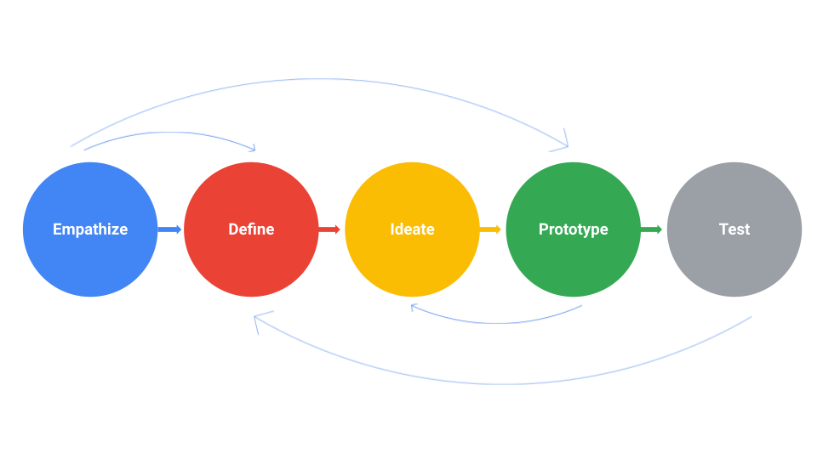

Take a moment to empathize with your audience’s needs. What takeaways are most important to them? Which data visualization would communicate that takeaway most effectively?

As you consider which kinds of data visualizations would be most useful, review the **decision tree** from earlier in this course. This will help you figure out what type of story you want to tell with your data.

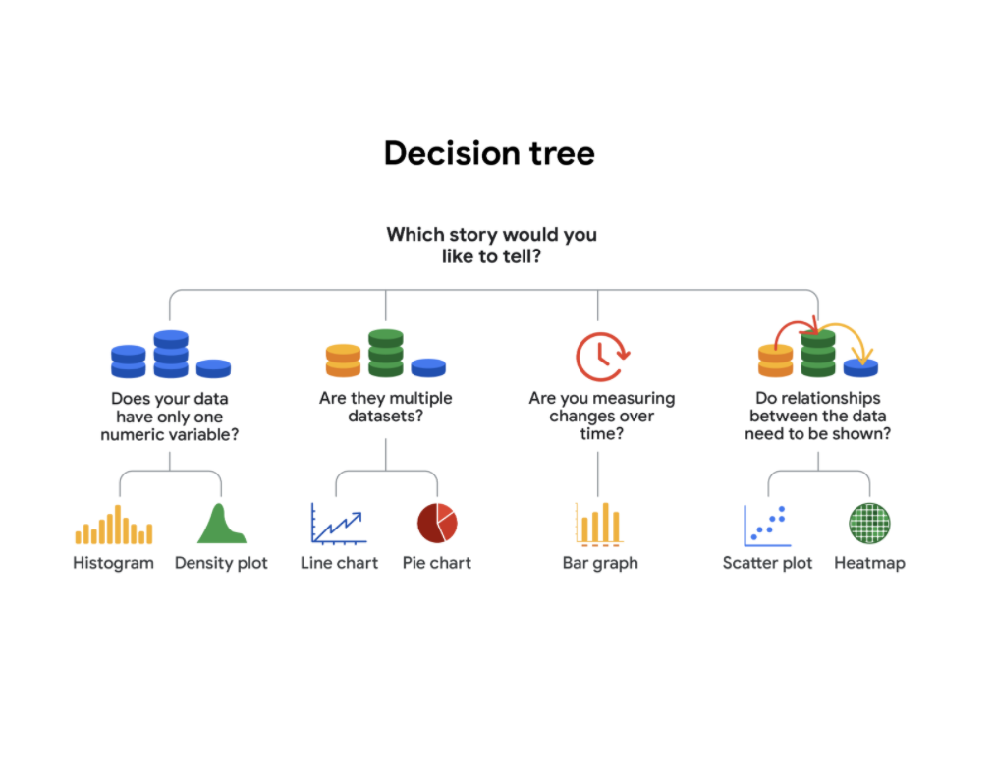

-Does your data have only one numeric variable? Histogram or Density plot

-Are there multiple data sets? Line chart or pie chart

-Are you measuring changes over time? Bar chart

-Do relationships between the data need to be shown? Scatter plot or heatmap

## **Create a prototype**



Now, use spreadsheet software to try out different visualizations of the data.

1. Highlight all cells by clicking on cell **A1** and dragging to **M3.** This should highlight all the data and headers aside from the **Total** column.

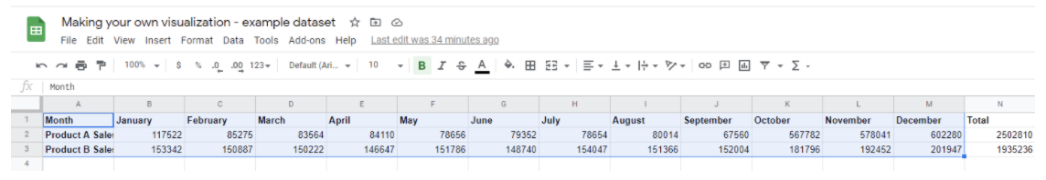

2. Click on the **Insert** tab and select **Chart.**

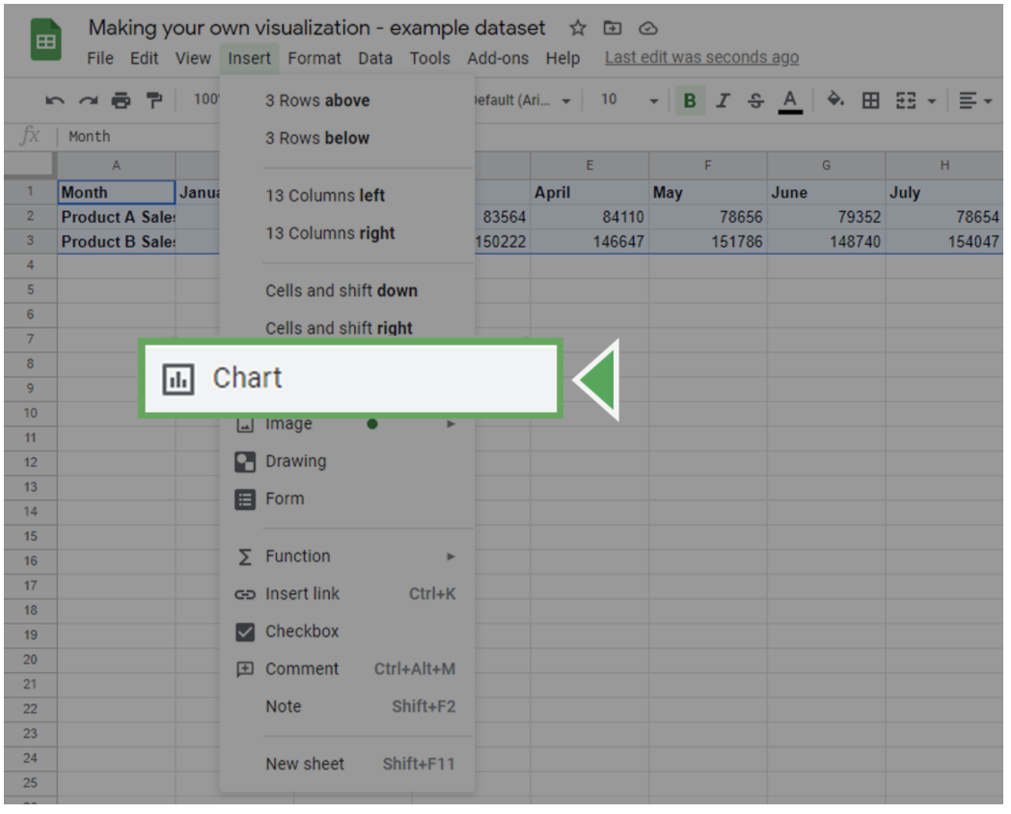

This will insert a chart object and bring up the **Chart editor** on the right side of the screen.

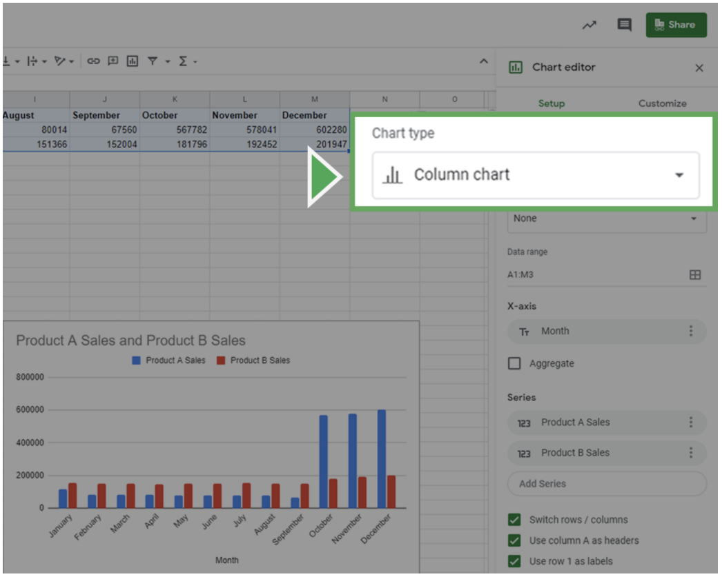

3. In the **Chart editor**, click on the **Setup** tab.

4. Click on the **Chart type** dropdown box. This will bring up the different kinds of charts you can create. Select the data visualization you think would be most useful during your design thinking process.

### **Customize your chart**



Now, customize your visualization by editing the titles, labels, and style.

Click on the **Customize** tab in the **Chart Editor**. Click on the **Chart & axis titles** dropdown to add an informative title or label your axes. Click the **Legend** dropdown to create a legend for your chart.

Once you decide on the style and labels, focus on the design elements of the chart. This is your chance to adjust elements such as color and font. For instance, you can change the color scheme of the chart in the **Chart Style** dropdown.

When creating data visualizations, **accessibility** is important. Set up your visualization in a way that is accessible and understandable by including highly contrasting colors.

Once you’re done customizing your chart, review your choices to ensure that your visualization is easy to understand.

* Do you think your audience will fully understand what they are observing within five seconds?
* Will they understand the key takeaway you’re trying to communicate after another five seconds?
* Did you use the most clear and communicative visualization style for your data?

If the answer to any of these questions is no, try different visualization styles and design choices. Experiment with colors, shapes, and chart types to find what makes it easier or harder to understand the message you are trying to convey.